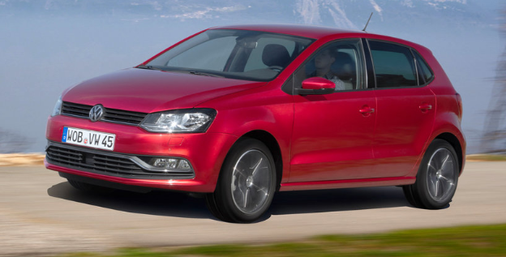

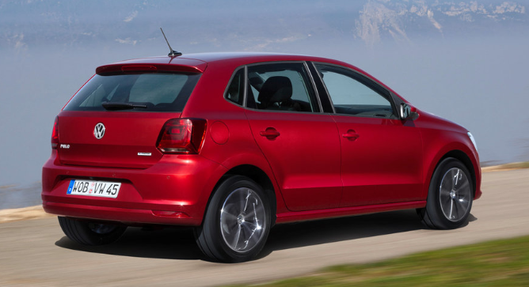

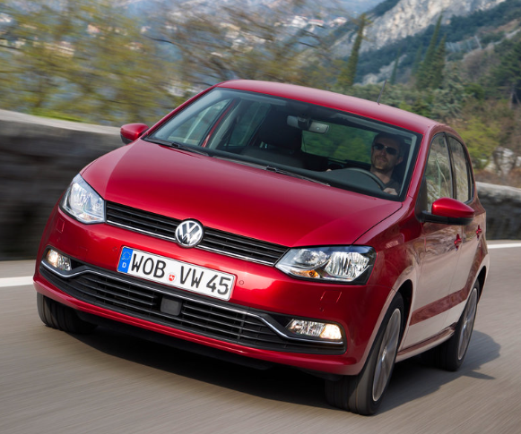

MAIN SPECIFICATION ON 5th Generation Volkswagen Polo

### 🔧 Powertrain & Performance

* **Engine options** (petrol):
  + 1.0 L I3 MPI – 60 PS (44 kW) or 75 PS (51 kW), 95–108 Nm; 0–100 km/h in ~15 s; ~160–174 km/h top speed
  + 1.2 L I3 MPI – 60 PS or 70 PS; 108–112 Nm torque; ~14–16 s to 100 km/h
  + 1.4 L MPI – 85 PS, 132 Nm; 0–100 km/h ~12 s; ~177 km/h top speed
  + 1.2 L TSI turbo – 90 PS or 105 PS; torque: 160–175 Nm; 0–100 km/h ~10.9–9.7 s; up to ~190 km/h
  + BlueGT (1.4 L TSI with cylinder deactivation) – 140 PS, 250 Nm; 0–100 km/h ~7.9 s; ~210 km/h
* **GTI variant**:
  + 1.4 L twin-charged – 180 PS; 250 Nm; 0–100 km/h in ~6.9 s; 229 km/h
  + 2015–17 facelift GTI: 1.8 L turbo, 192 PS, 320 Nm; 0–100 km/h ~6.7 s; 235 km/h
* **Diesel options**:
  + 1.6 L TDI variants: 75–105 PS; 96–250 Nm; Bluemotion down to ~3.6 L/100 km
  + **Transmissions**
* Manual: 5- or 6-speed
* DSG dual-clutch: 7-speed available (TSI and diesel)

**⛽ Fuel Economy & Emissions**

* TSI 1.0: ~5.2–5.5 L/100 km, ~106–108 g CO₂/km
* BlueMotion diesel: ~3.6 L/100 km, ~96 g/km CO₂

**📏 Dimensions & Cargo**

* **Length**: ~3,970 mm (pre-facelift); ~4,053 mm after 2018 MQB A0 update
* **Width**: ~1,682 mm / 1,751 mm (facelift)
* **Height**: ~1,453 mm / ~1,446 mm
* **Wheelbase**: ~2,470 mm (PQ25 platform)
* **Boot Volume**: 280 L (up to 952 L folded)
* **Kerb Weight**: ~1,130–1,230 kg

**🛋 Interior & Features**

* Quality improved significantly post‑2014 facelift
* Available infotainment: touchscreen nav system, Volkswagen’s Active Info Display (digital cluster) on higher trims

**🛡 Safety**

* Achieved 5-star Euro NCAP safety rating
* Standard airbags (front, side, curtain), ABS, ESP; optional safety assist features added to higher trims post‑facelift

**✅ Quick Overview**

| **Aspect** | **Mk5 Polo Highlights** |
| --- | --- |
| Engines | 1.0–1.4 L petrol, 1.6 L diesel, GTI variants |
| Power Range | 60–192 PS; torque 95–320 Nm |
| Transmissions | 5/6MT, 7-speed DSG dual-clutch |
| Fuel Economy | From ~3.6 L/100 km (diesel) up to ~5.5 L/100 km (petrol) |
| Dimensions | ~3.97 m long; ~280 L boot |
| Weight | ~1,130–1,230 kg |
| Safety | 5-star Euro NCAP, full ADAS suite on later models |